**Name: Session:**

**Programming II**

**Lab Exercise 2.17.2022**

1. Create an application that displays your name and address when a button is clicked as shown below. The form should have 3 labels names lblName, lblStreet, lblCityStateZip and have a Font property of Times New Roman, bold, 12 point with the labels TextAlign property set to MiddleCenter.

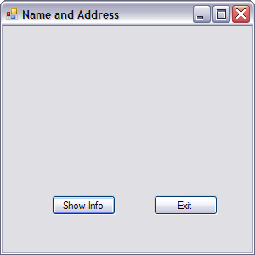 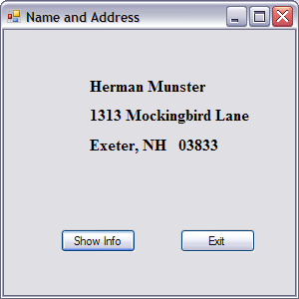

1. Create a Math Tutor application. The application should display a simple math problem in a Label control. The form should have a button that displays the answer in the same Label. The form should have a second button that closes the application.

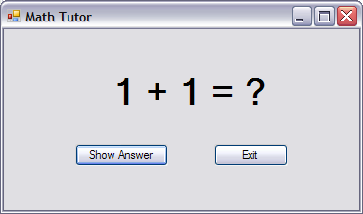 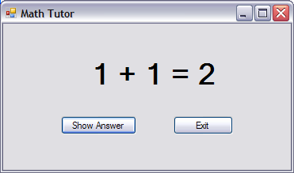

**When you have completed these two applications, submit your source code and a screen shot of your running application.**